Annex: Test case terminal outputs

## Valid User login

## 

## Invalid User Login

## 

## 

## Incorrect Password

## 

## 

## Password Change Functionality

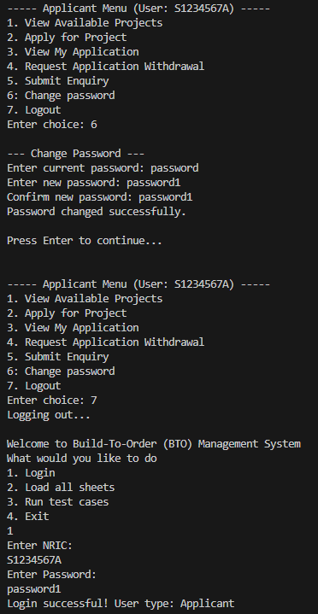

## Project Visibility Based on User Group and Toggle

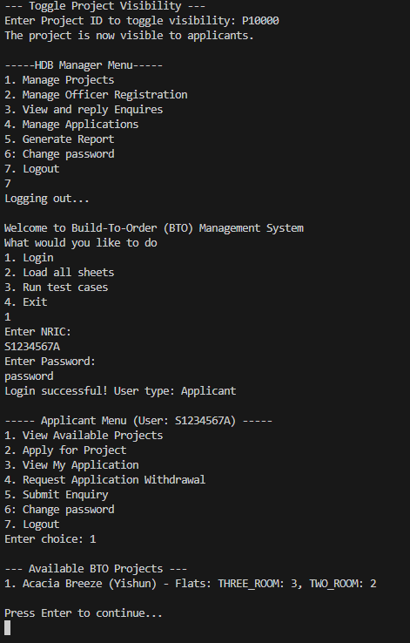

## 

## Project Application

## Viewing Application Status After Visibility Toggle Off

## 

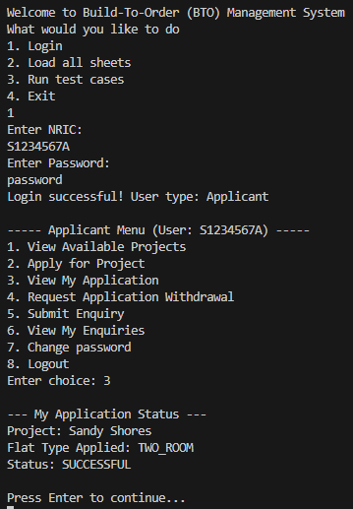

## 

## Single Flat Booking per Successful Application

Note: After test case 6/7, Applicant unable to apply for projects anymore

## 

## 

## Applicant’s enquiries management

Applicant submit enquiry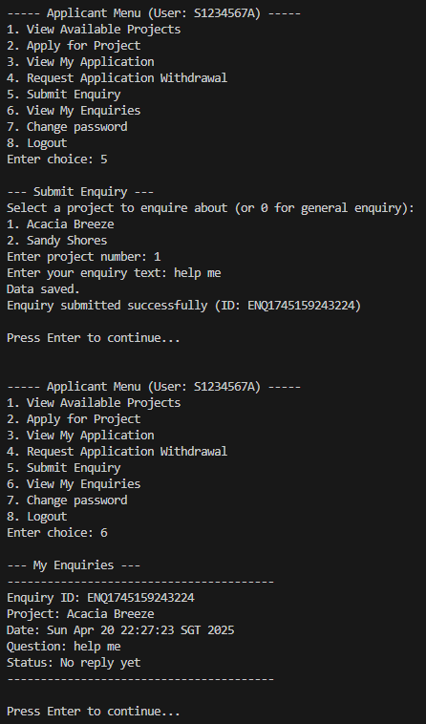

Update to Applicant

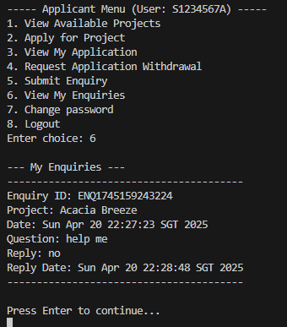

## HDB Officer Registration Eligibility

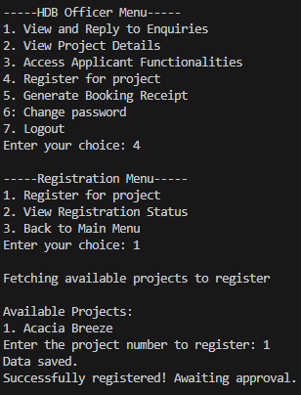

## HDB Officer Registration Status

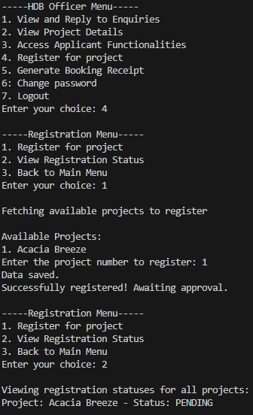

## Project Detail Access for HDB Officer

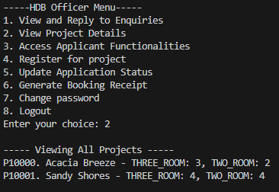

## 

## Restriction on Editing Project Details

Officer menu no mention of edit project  
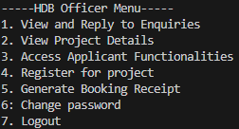

Manager menu edit functionality

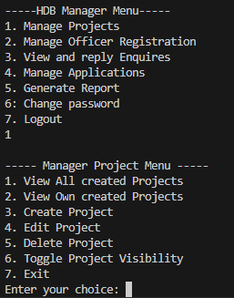

## 

## Response to Project Enquiries

## 

## Flat Selection and Booking Management

## 

## Receipt Generation for Flat Booking

## 

## 

## Create, Edit, and Delete BTO Project Listings

Create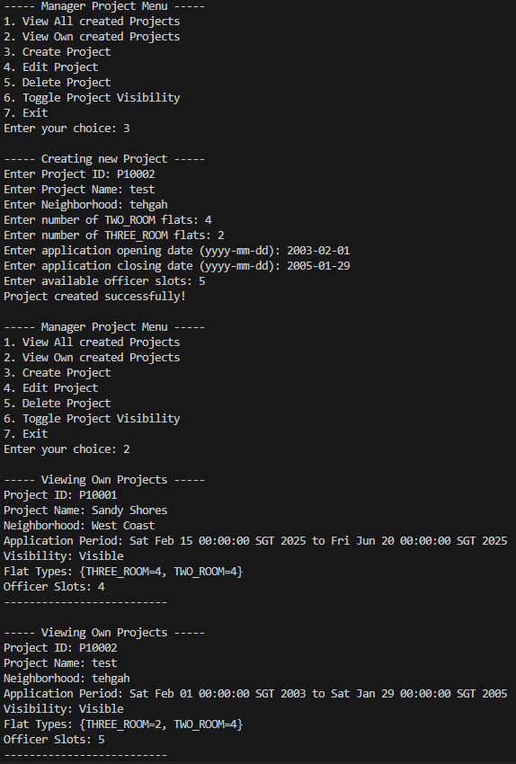

Edit

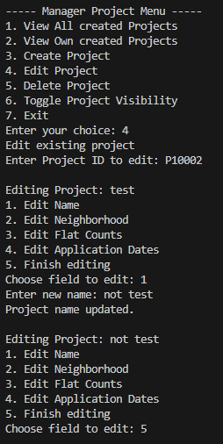

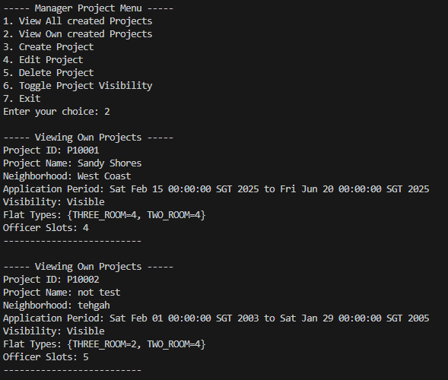

Delete

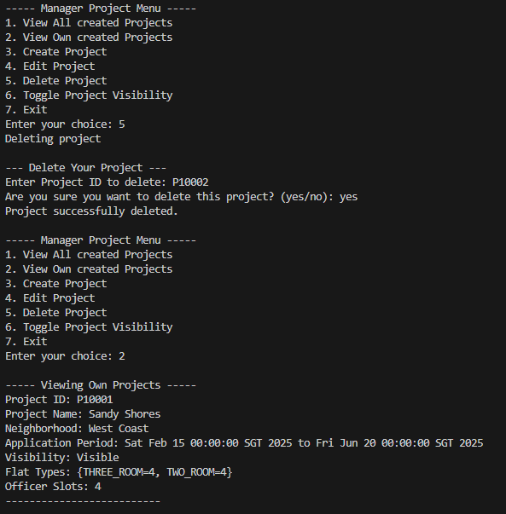

## 

## Single Project Management per Application Period

Manager incharge of project within application period cannot create (Michael)

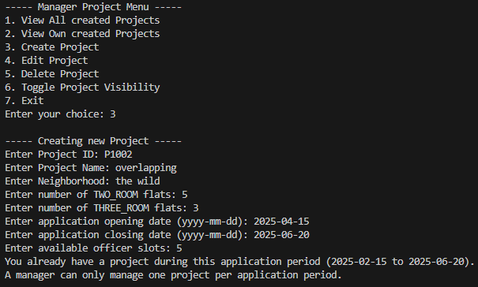

Manager not in charge of project can create (Jessica)

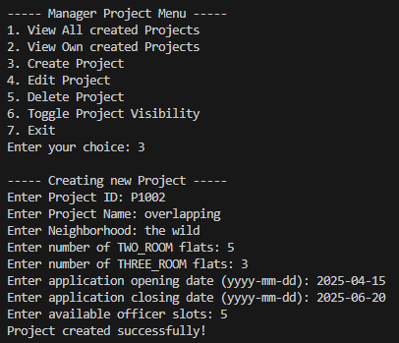

## Toggle Project Visibility

## 

## 

## View All and Filtered Project Listings

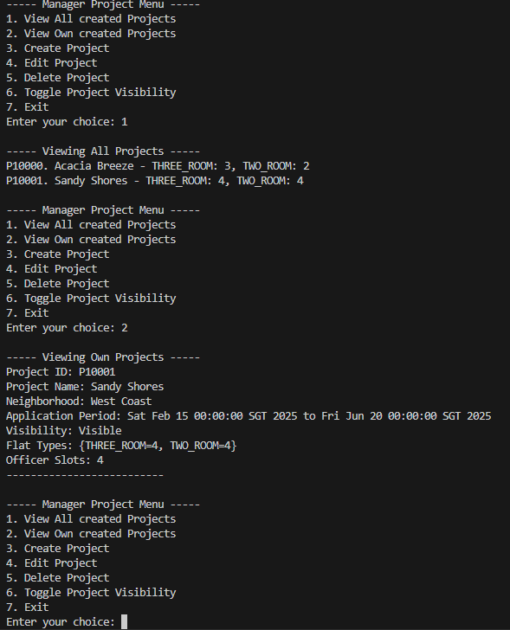

## 

## Manage HDB Officer Registrations

HDB Manager managing officer registrations

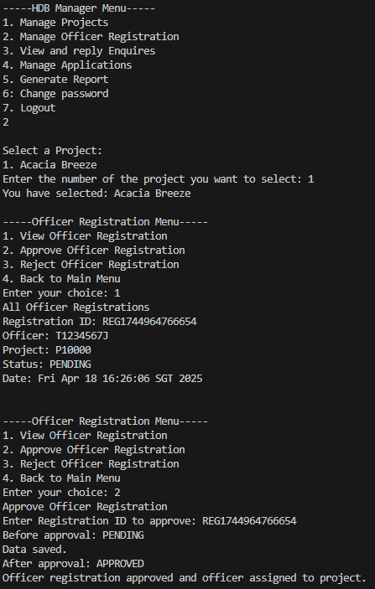

Change to HDB Officer registration after HDB manager log out

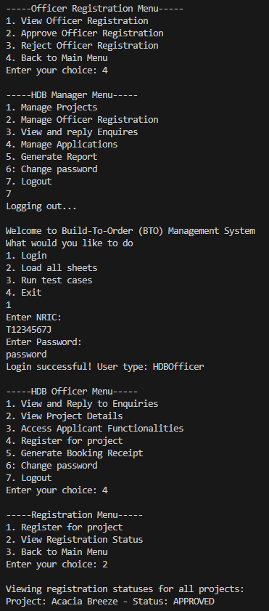

## Approve or Reject BTO Applications and Withdrawals

Once approved Application is removed

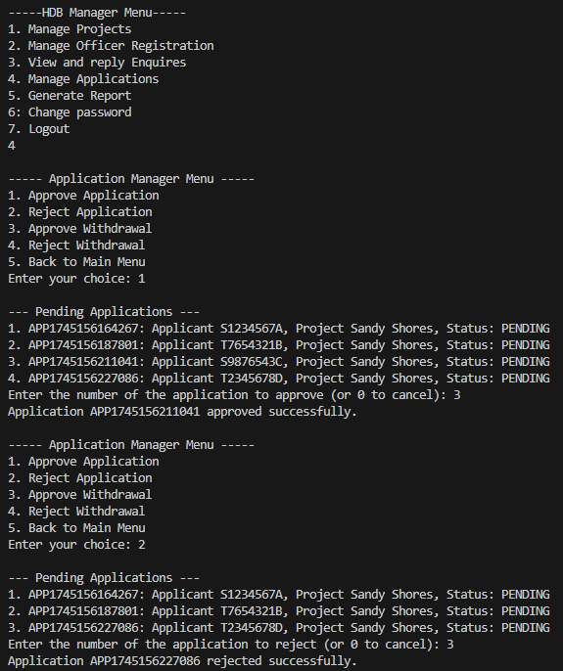

Once withdrawal approved or rejected, it it removed from withdrawal requests

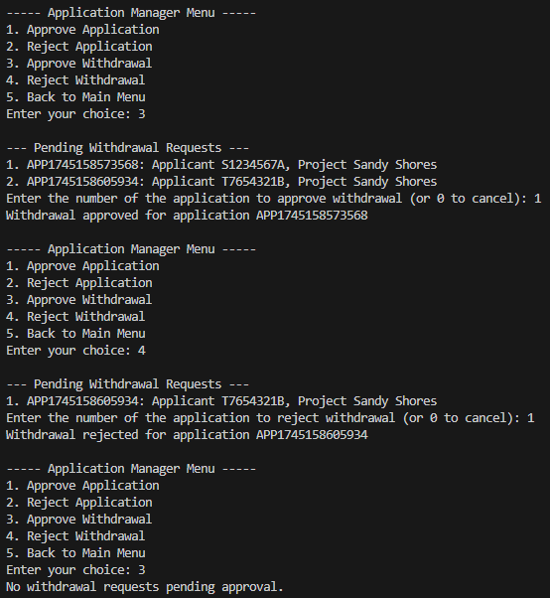

Approve application

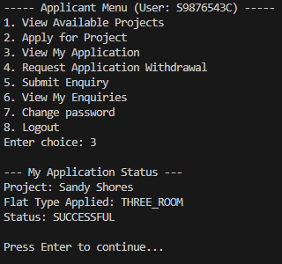

Reject Application

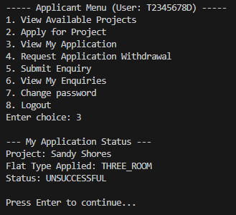

Approved withdrawal

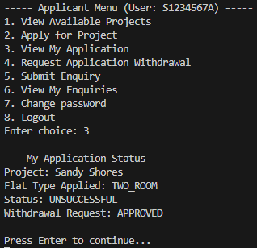

Reject withdrawal (application placed set as pending again)

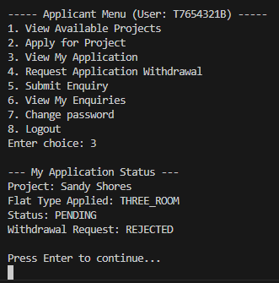

## 

## Generate and Filter Reports

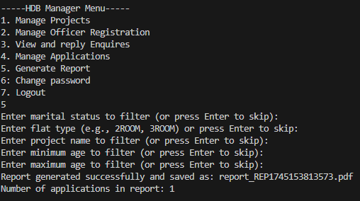

No filter applied

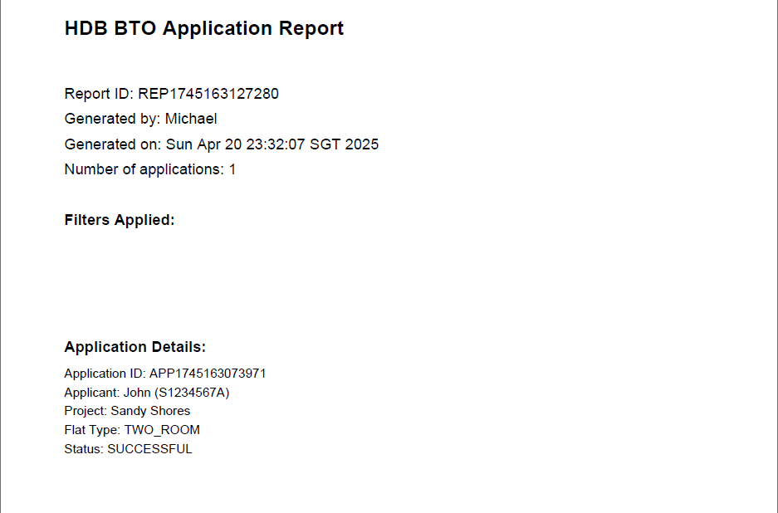

Three_room filter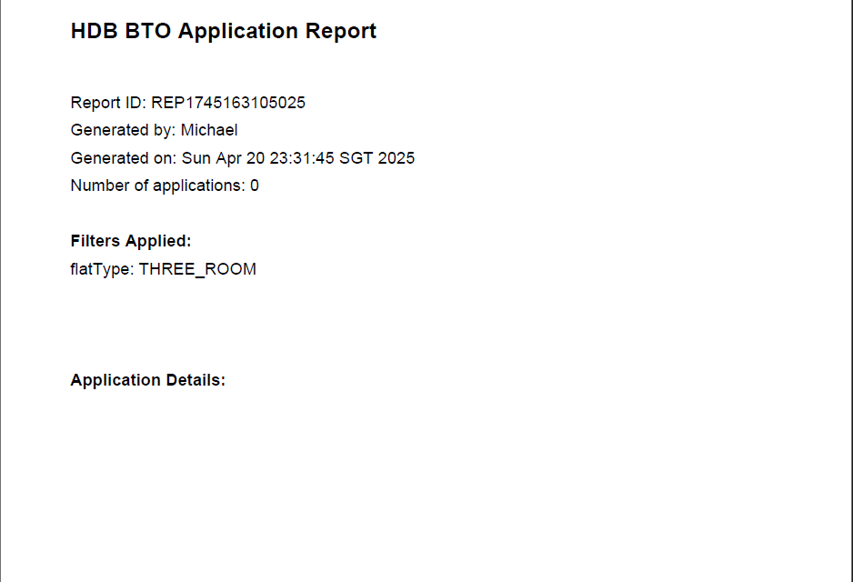Two_room filter